Project1

Multiple Criteria Decision Analysis

A New Student Housing Siting

Yan Zhang & Haoxing Deng
Professor Siqin (Sisi)Wang
SSCI 583 Spatial Analysis and Modeling
February 4, 2025

Project Link: https://uscssi.maps.arcgis.com/home/item.html?id=e552f2283be74e7b9c42d1248954be38

Individual Contribution:
Preparation and software operation:
Yan Zhang:
Data source searching, workflow making, weighted overlay analysis, figure making
Haoxing Deng:
Data preprocessing, fuzzy overlay analysis, region locating, workflow revising
Completion of the report:
Yan Zhang:
Study areas, General Data Preparation and Analysis Methods, Results
Haoxing Deng:
Introduction, Criteria and constraints, Data table, Discussion, Report layout setting

1.Instruction
San Francisco is the city with the second-highest population density in the United States. It has the highest rent prices and one of the highest crime rates in the country. Undeniably, this poses a significant threat to student safety. Therefore, the goal of this project is to carefully evaluate and select a suitable student housing option. The evaluation is based on four key indicators: slope, impervious rate, distance to police stations, and road density.

2. Study Area

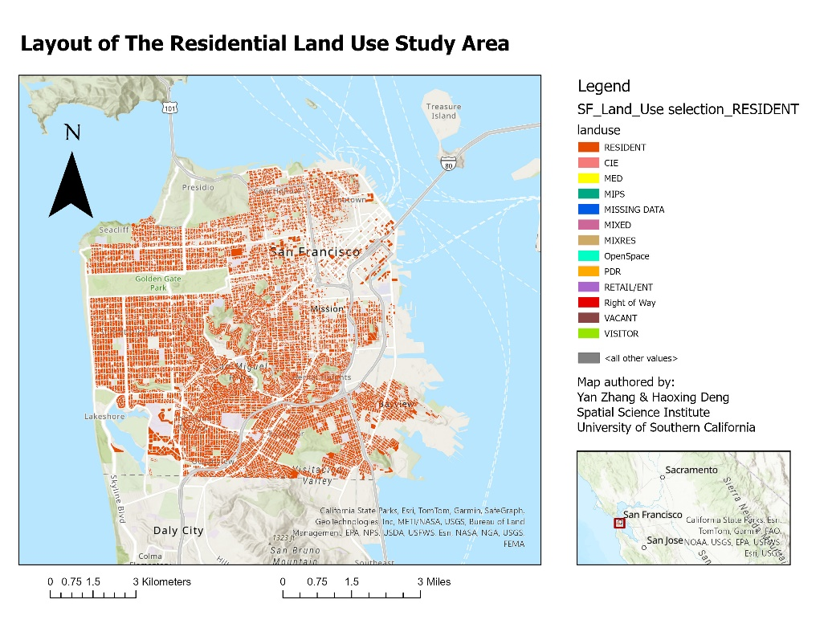
Our study area is primarily within the San Francisco metropolitan area on the Peninsula, excluding the surrounding islands and other outlying areas, and extends from latitudes 37.7 degrees to 37.83 degrees north and longitudes 122.35 degrees to 122.52 degrees west. The new student housing will primarily focus on land planning that functions as a residence.
Figure1: Layout of the Residential Land Use Study Area

3. Methods

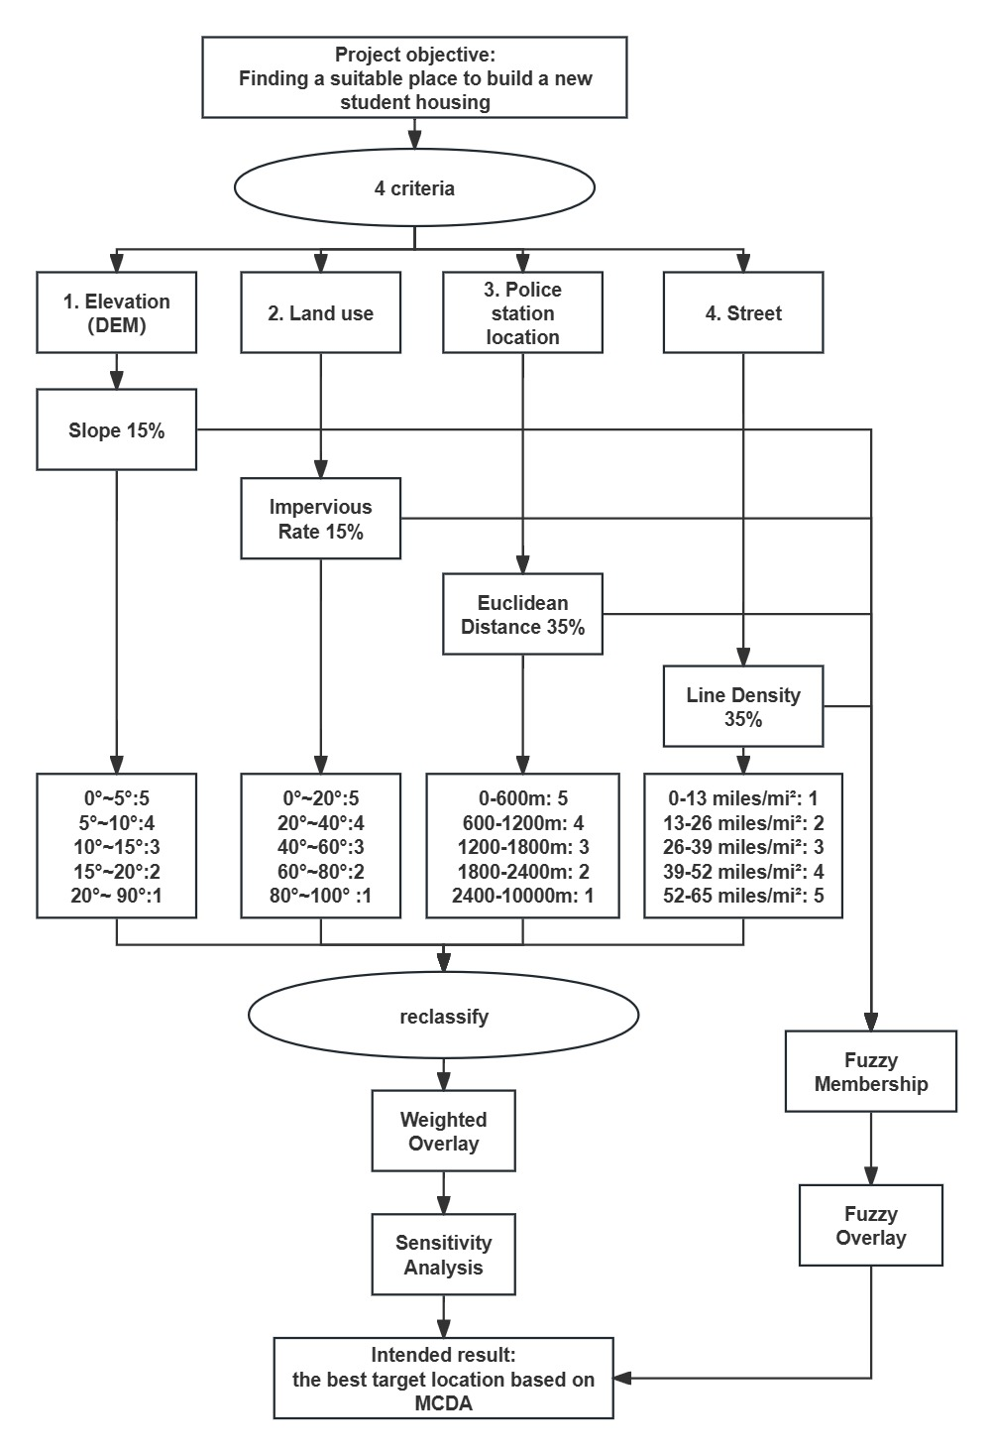
3.1 Workflow

Fig2 Workflow

3.2 Criteria and data source
Slope: Flat and low-lying areas are generally more appropriate for construction, as they provide stability and reduce the complexity and cost of building. Ideally, a slope between 0 to 10 degrees is considered optimal for constructing student housing.
Impervious rate: Impervious rate is another crucial factor, particularly for a city like San Francisco, which is close to the sea and prone to challenges such as flooding and stormwater runoff. The impervious nature of the ground determines how efficiently water can drain through the soil, reducing the risk of flooding.
Distance to police stations: The proximity to a police station is an essential aspect of student housing planning. The presence of law enforcement nearby enhances the sense of security, which is a priority for both students and their families. Accessibility to police services ensures timely assistance in emergencies, fostering a safe living environment.
Road density: High Road density enhances connectivity and accessibility, making it easier for students to commute to educational institutions, workplaces, and other essential facilities.

3.3 Data table
Table 1 Data Table
Dataset | Criteria | Source | Directly or indirectly
Slpoe_DEM_10 | Slope | DataSF | Indirectly
Annual_NLCD_Fctlmp | Impervious rate | MRLC | Direct
Police_Stations_2013 | Police Station | DataSF | Indirectly
LineDen_SF_S2 | Road density | DataSF | Indirectly

3.4 General Data Preparation
Four criteria were chosen for the location of new student housing: distance from the police station, density of surrounding roads, slope, and imperviousness of the land.
The closer to the police station the safer it is, the higher the road density the easier it is to travel, the flatter the ground the better it is for new housing, and the lower the imperviousness of the land the more potential it has for new housing because it is undeveloped. We started by downloading the police station address from the City of San Francisco's public data site, splitting the location columns into longitude and latitude columns in a csv file, and converting it to a vector layer using the XY Table to Point tool. After using the Euclidean distance tool, the distance to the police station was divided into 5 levels, each 600 meters apart, with the last level greater than 2400 meters. Use the Reclassify tool to score the five levels from 5 to 1 in order of closest to farthest.
The streets of San Francisco were analyzed using the Line Density tool to create a new layer, the density was manually divided into five equal intervals in the symbology, and then the Reclassify tool was used to assign values from 1 to 5 to the densities from low to high.
Use the slope tool to convert the DEM layer into a slope raster map, the slope will be divided into five levels in the symbology, set the first four intervals of 5 degrees, the last level of 20 to 90 degrees, using the reclassify tool to score 5 to 1 from low to high respectively.
From the MRLC website, go into NCLD viewer, focus the map on San Francisco, intercept the area and download a portion of the impervious surface, average the imperviousness into 5 levels of 20% each in the symbology, and then use the reclassify tool to score it from 5 to 1 on a scale of low to high, respectively.
We considered the fact that the decision to choose a good or bad location depends largely on safety and convenience, so both the distance to the police station and the density of the road were given a weight of 35%. As for problems in the construction process, imperviousness and slope were both given a weight of 15%.
Index | Range |  |  |  |  | Weight | Sensitivity Test
Reclassification | 1 | 2 | 3 | 4 | 5
Impervious Rate | 0%-20% | 20%-40% | 40%-60% | 60%-80% | 80%-100% | 15% | 20%
Street density | 0-13 miles/mi² | 13-26  miles/mi² | 26-39 miles/mi² | 39-52 miles/mi² | 52-65 miles/mi² | 35% | 30%
Distance to the police station | 0-600 m | 600-1200 m | 1200-1800 m | 1800-2400 m | 2400-10000 m | 35% | 30%
Slope | 0°-5° | 5°-10° | 10°-15° | 15°-20° | 20°-90° | 15% | 20%
Table 2 Date Preparation

3.4 Method Analysis
Using the fuzzy membership tool to manipulate each of these four criteria, for road density we prefer areas with larger values so we choose a membership type of LARGE; for imperviousness we prefer smaller rather than the smallest type so we choose a membership type of MS SMALL because the smallest types are usually lakes and oceans; and for both distance from police station and slope we choose a membership type of SMALL because both criteria are better with smaller value. When performing fuzzy overlay tool, since we want to satisfy all conditions, not any of them or highlight the characteristics of different criteria, it is most appropriate to choose AND as the overlay type, rather than ‘OR’ or ‘SUM’.
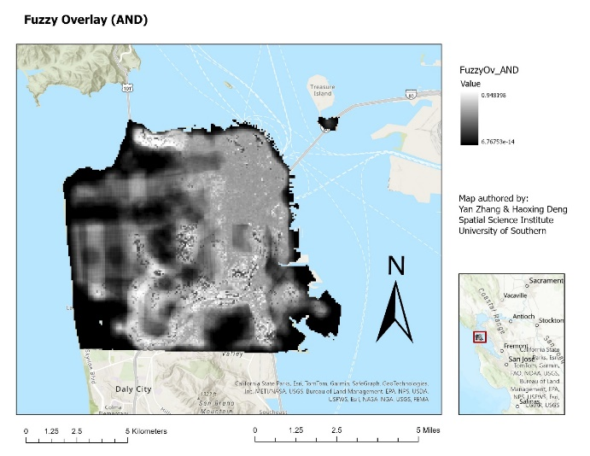
Figure 3 Fuzzy Overlay (AND)
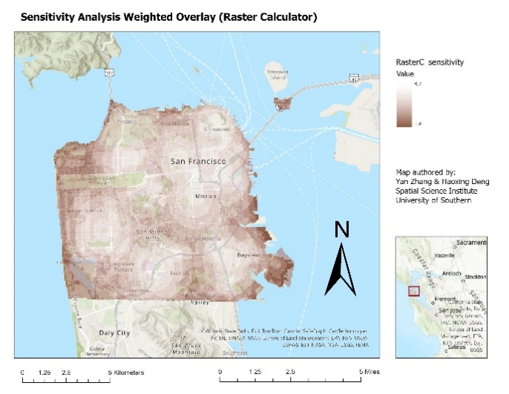
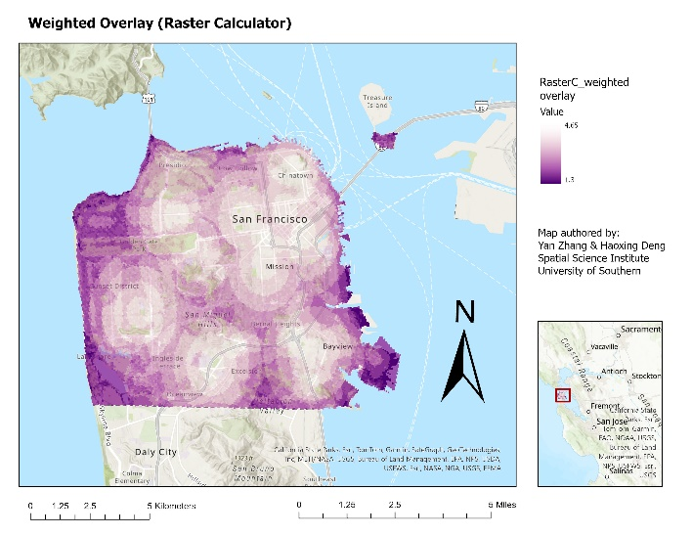
Using Raster Calculator tool and replacing the white color at one end of the color scheme with a transparent color, Northeast San Francisco scores higher, due in large part to the fact that both the road density and the distribution of police stations are largely concentrated there. The sensitivity analysis was conducted by changing the weights to 30% for both distance from the police station and road density, and 20% for the other two, and the results were generated and found to make little difference.
Fig4a Weighted Overlay Fig4b Sensitivity Analysis Weighted Overlay

4. Results
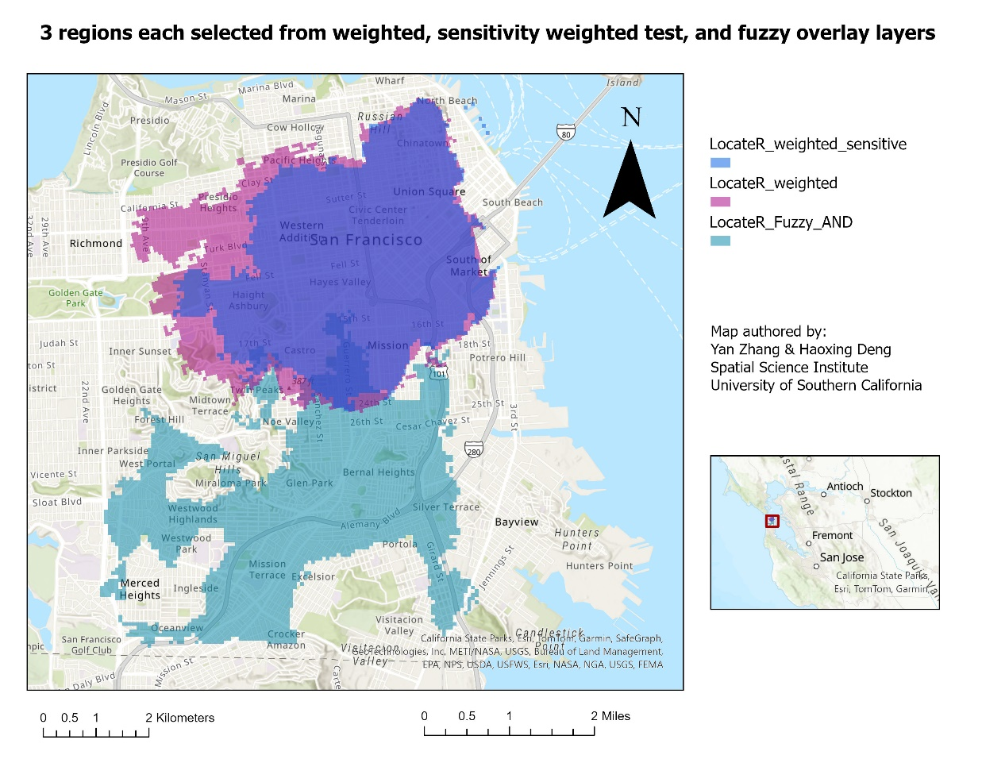
Using the Locate Region tool, the appropriate raster cells were generated for the Weighted Overlay, Sensitivity Analysis and Fuzzy Overlay methods respectively, making the layers semi-transparent to better see what areas they covered and putting them together. Found that the weighting method and fuzzy method to generate the layer is very different. After sensitivity analysis and reweighting, the adjusted layer is slightly smaller than the original, but the shape is basically unchanged. Perhaps the areas covered by all three layers, the Mission Dolores Park neighborhood, and along Guerrero Street east of the Castro would be better suited for new student housing.
Fig5 Final Map
5.Discussion
This project highlights key indicators—slope, impervious rate, distance to police stations, and road density—essential for selecting suitable student housing in San Francisco. By applying Weighted and fuzzy logic, it identifies optimal locations such as Mission Dolores Park with higher safety and convenience. These findings enhance the understanding of urban housing dynamics, guiding policymakers in improving student housing accessibility and safety standards.
However, limitations exist, including potential biases in indicator weighting and the exclusion of broader socio-economic factors. Future research should address these gaps to ensure a comprehensive evaluation of urban housing options, emphasizing the need for adaptive methodologies in a changing urban landscape.

References
Musakwa, Walter. “Identifying Land Suitable for Agricultural Land Reform Using GIS-MCDA in South Africa.” Environment, Development and Sustainability 20, no. 5 (2018): 2281–99. https://doi.org/10.1007/s10668-017-9989-6.
Marsh, Kevin, Maarten IJzerman, Praveen Thokala, Rob Baltussen, Meindert Boysen, Zoltán Kaló, Thomas Lönngren, et al. “Multiple Criteria Decision Analysis for Health Care Decision Making—Emerging Good Practices: Report 2 of the ISPOR MCDA Emerging Good Practices Task Force.” Value in Health 19, no. 2 (2016): 125–37. https://doi.org/10.1016/j.jval.2015.12.016.
Watkins, Lance, Heidi E Brown, Ladd Keith, Erika Austhof, Hsini Lin, Samuel N Chambers, Joseph Tabor, Aaron Gettel, and Melissa Guardaro. “A Co‐Produced Workflow for Addressing Inequities in Cooling Center Access.” Community Science (Hoboken, N.J.) 3, no. 4 (2024). https://doi.org/10.1029/2023CSJ000038.
Long, Xiaoyu, Luyao Wang, and Weipeng Li. “Geographical Influences on Job–Housing Balance: A Study of Coastal Urban Areas in Boston.” Sustainability 15, no. 22 (2023). https://doi.org/10.3390/su152215920.
Narendr, Aishwarya, S Vinay, Bharath Haridas Aithal, and Sutapa Das. “Multi-Dimensional Parametric Coastal Flood Risk Assessment at a Regional Scale Using GIS.” Environment, Development and Sustainability 24, no. 7 (2022): 9569–97. https://doi.org/10.1007/s10668-021-01839-6.

